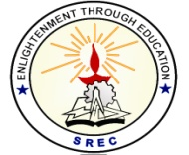**SRI RAMAKRISHNA ENGINEERING COLLEGE**

[Educational Service: SNR Sons Charitable Trust]

[Autonomous Institution, Reaccredited by NAAC with ‘A+’ Grade]

[Approved by AICTE and Permanently Affiliated to Anna University, Chennai]

[ISO 9001:2015 Certified and all eligible programmes Accredited by NBA]

VATTAMALAIPALAYAM, N.G.G.O. COLONY POST, COIMBATORE – 641 022.

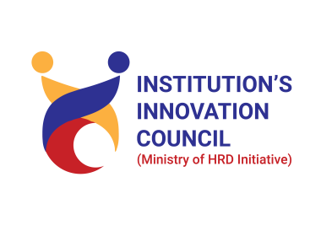

**SREC CoIN – MoE’s Institution Innovation Council 6.0**

|  |  |
| --- | --- |
| **S.No.** | **CONTENTS** |
|  | Permission Letter |
|  | Report |
|  | Photos (With Geotag) |
|  | Poster |
|  | Resource Person Profile |
|  | Attendance |
|  | Feedback |
|  | Certificate(if any) |
|  | Bill Settlement (Along with proof) |

**Note:** Also requested to upload the soft copy details in the given Google form link https://forms.gle/n7WtpAKgtxTmxYMN8

**SRI RAMAKRISHNA ENGINEERING COLLEGE**

[Educational Service: SNR Sons Charitable Trust]

[Autonomous Institution, Reaccredited by NAAC with ‘A+’ Grade]

[Approved by AICTE and Permanently Affiliated to Anna University, Chennai]

[ISO 9001:2015 Certified and all eligible programmes Accredited by NBA]

VATTAMALAIPALAYAM, N.G.G.O. COLONY POST, COIMBATORE – 641 022.





**SREC CoIN – MoE’s Institution Innovation Council 6.0**

***Report on World Intellectual Property Day Celebration***

**ACADEMIC YEAR:** 2023-2024

**ACTIVITY:** IIC Celebration Activity

**QUARTER:** Q3

**PROGRAM / ACTIVITY NAME: World Intellectual Property Day Celebration**

**PROGRAM TYPE**: Competition

**PROGRAM THEME:** IPR & Technology Transfer

**DURATION OF THE ACTIVITY (In Hrs): 6** Hours

**START DATE: 26.04.2024**

**END DATE: 26.04.2024**

**NO. OF STUDENT PARTICIPANTS: 30**

**NO. OF FACULTY PARTICIPANTS: 30**

**NO. OF EXTERNAL PARTICIPANTS (If any): Nil**

**EXPENDITURE AMOUNT (If any):3000/-**

**VENUE: CSE SEMINAR HALL**

**MODE OF DELIVERY:** Offline

**OBJECTIVE: (Max 100words)**

The main objective of conducting this event To increase awareness about the importance of intellectual property rights among participants.Many people may not fully understand what intellectual property rights are or how they impact various aspects of society and the economy.

Educate participants about different types of intellectual property rights such as patents, trademarks, copyrights, and trade secrets,and Encouraging participants to think critically and creatively about intellectual property issues, fostering an environment that supports innovation, and recognizing individuals or teams for their contributions in this field.

Helping participants to understand the legal aspects of intellectual property rights, including the processes involved in obtaining and enforcing these rights.

**BENEFITS IN TERMS OF LEARNING / SKILL/ KNOWLEDGE OBTAINED:**

**(Max 150 words)**

* SREC IPR IQ and Patent Drafting competiion on behalf of the world intellectual property day conducted by SREC CoIN, MoE-IIC in association with SREC IPR Cell on 26.04.2026.
* There were 30 participants from various department of SREC participated in the Quiz Event-**Unlock the IPR IQ** and Idea Pitching Competition-**Come with an Idea and Go with a Patent**.
* participating in a quiz event gives students a sense of achievement and provides a platform for recognition of their academic efforts. Successfully answering questions in a quiz boosts students' confidence in their knowledge and abilities.
* Students participate in teams of 3-5 members, encouraging collaboration and peer learning and they are actively designed their idea by featuring rapid-fire questions or themed challenges which add excitement and intensity to the competition.
* In the morning session ,Quiz event was conducted by Mr.V.Krishnakumar through online tool and evaluated by Internal Jury member Dr.R.Kingsy Grace,From that 3 students were selected and received their cash prizes.

Prize Winner list

1. D.Manjudevi ,R&A - 700/-
2. M.manobharathi, - 500/-
3. V.Sudeesh - 300/-

* In the evening session ,Idea Pitching event was conducted by Mrs.T.Thenmozhi and evaluated by Dr.A.Kingcy Grace,4 Teams has been short listed and won prize money of 1500/-.

Prize Winner List

1. Agilan & Team - 500/-
2. Manobharathi &Team - 400/-
3. Farafathima Team - 300/-
4. Sudeesh &Team - 300/-

**PHOTOGRAPHS**

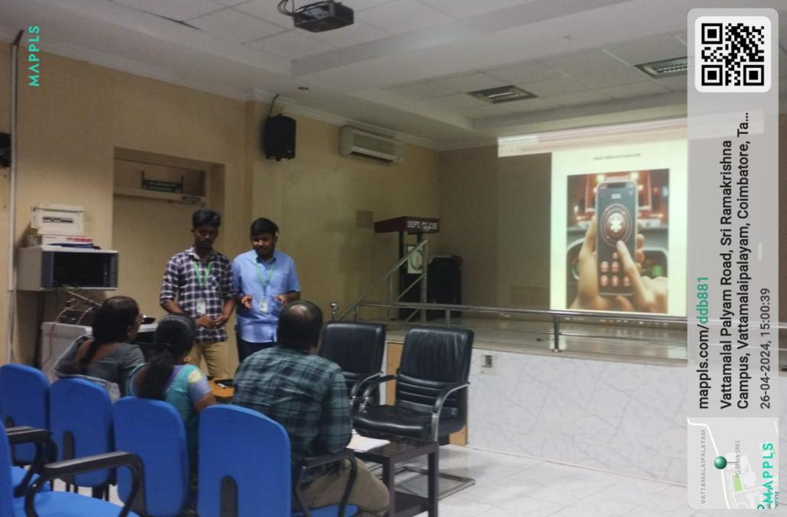

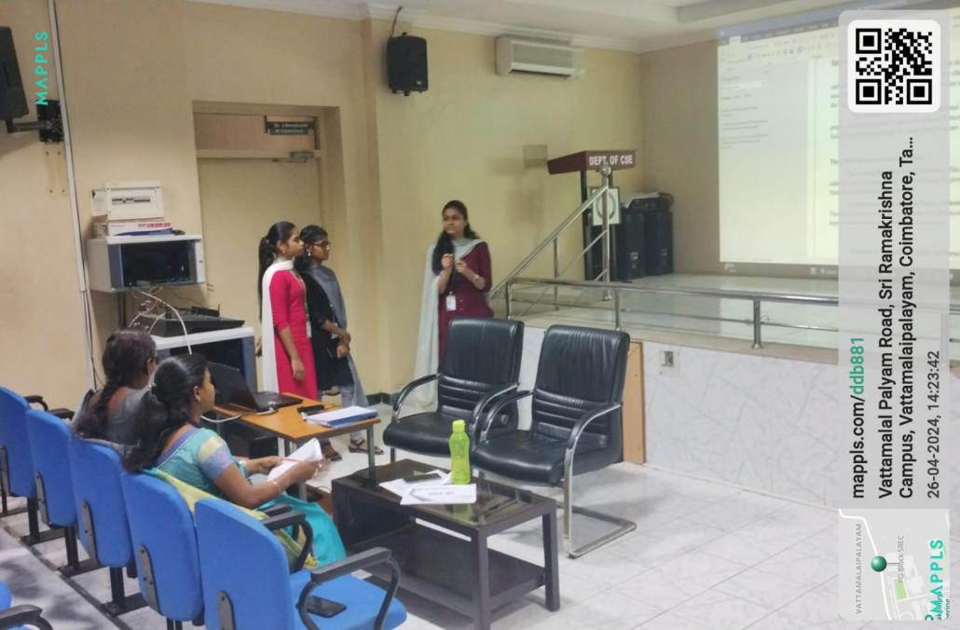

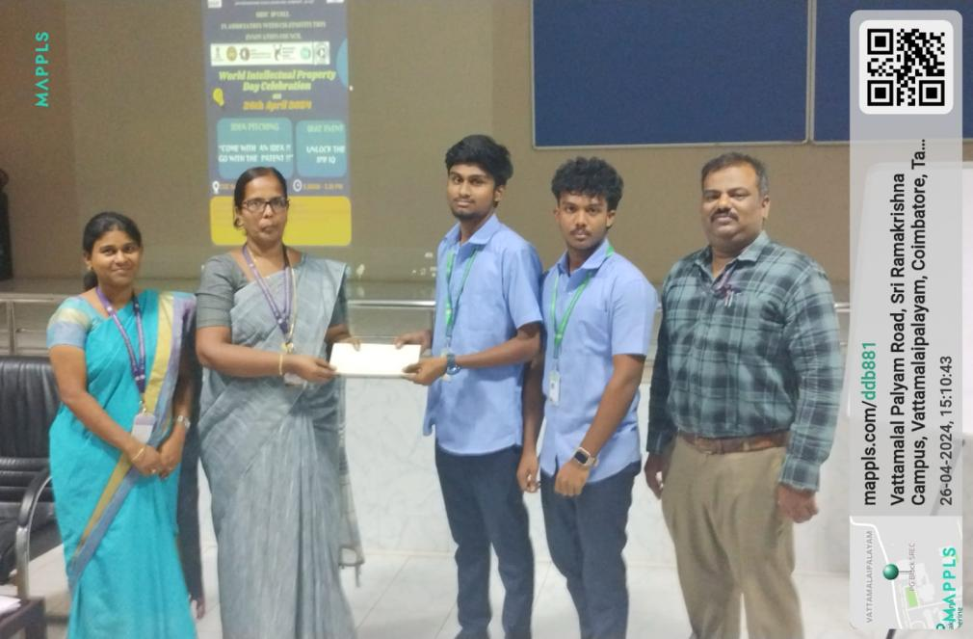

**POSTER DESIGN OF THE EVENT-**

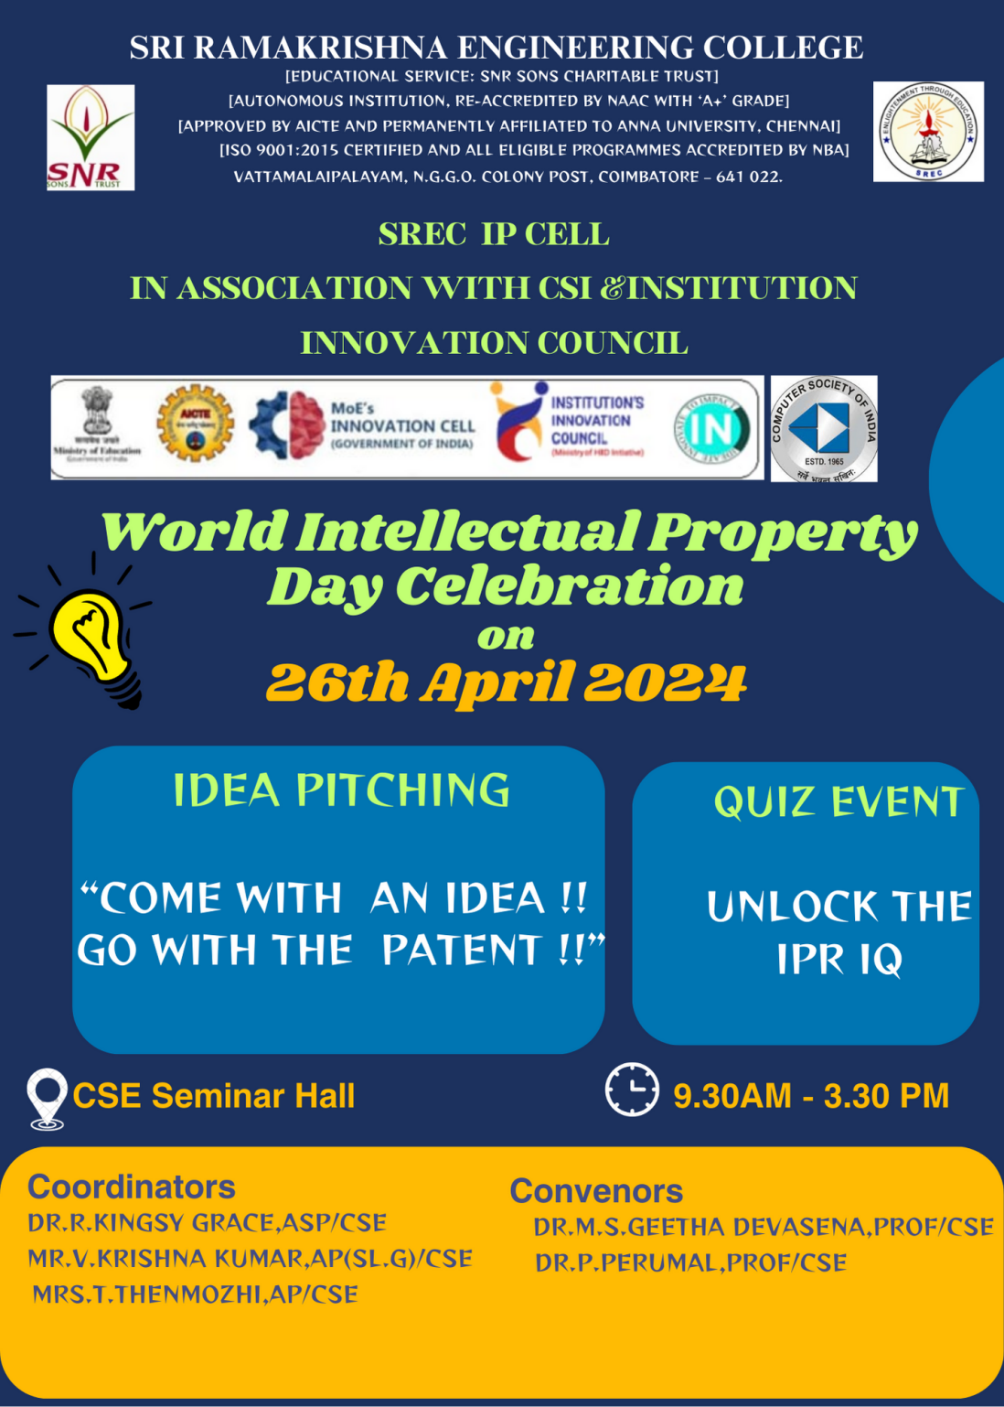

**PROMOTION IN SOCIAL MEDIA:** Twitter / Facebook / Instagram / LinkedIn

**RESOURCE PERSON PROFILE**

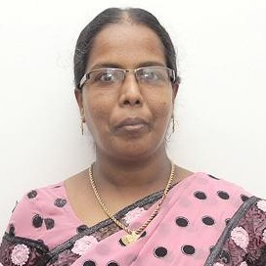

Experienced Associate Professor with a demonstrated history of working in the higher education industry. Skilled in Python (Programming Language), C++, and Basics of HPC related Languages. Strong education professional with a PhD focused in “Efficient Replica Placement and Selection Algorithms in Data Grid” from Anna University. She holds her Master of Engineering in Computer Science and Engineering from Karunya Institute of Technology in 2005 and Bachelor of Engineering in Computer Science and Engineering from Noorul Islam College of Engineering in 2003. She has 17 years of academic experience with Sri Ramakrishna Engineering College. Her research areas include Grid and Cloud Computing and HPC. She has about 30 technical and research publications to her credit in International Journals, International and National conferences. Her Paper in Journal of Parallel and Distributed Computing (Elsevier) appeared in SCIENCEDIRECT TOP 25 LIST OF MOST DOWNLOADED ARTICLES during January to March 2014 and also in Top Cited articles list.

**MoE IIC-Coordinators MoE IIC-Convenor President-IIC**

Mrs.G.Rathi Dr.N.R.Alamelu